Title:
LLM-Based Car Lease Contract Review and Fairness Analysis System
Prepared by:
Vidhya Shree A
Technology:
FastAPI, OCR (Tesseract), LLM, Python

1.Introduction :
Car lease agreements are legally complex documents containing important financial and contractual obligations. Due to their lengthy structure and legal terminology, users often struggle to understand critical clauses such as penalties, mileage limits, and termination conditions. This project proposes an AI-based system that uses Optical Character Recognition (OCR) and Large Language Model (LLM) techniques to automatically extract, analyze, and evaluate lease contracts. The system aims to improve transparency, fairness, and user awareness in car leasing decisions.

2.Problem Statement:
Car lease contracts create an imbalance between leasing companies and customers because essential terms are hidden within complex legal language. Manual analysis is time-consuming and error-prone, causing users to unknowingly accept unfair conditions.

3.Objectives:
- Extract structured lease data from scanned documents
- Convert unstructured legal text into JSON format
- Analyze contracts for fairness and transparency
- Detect risky or unfair clauses
- Provide clear and understandable insights to users

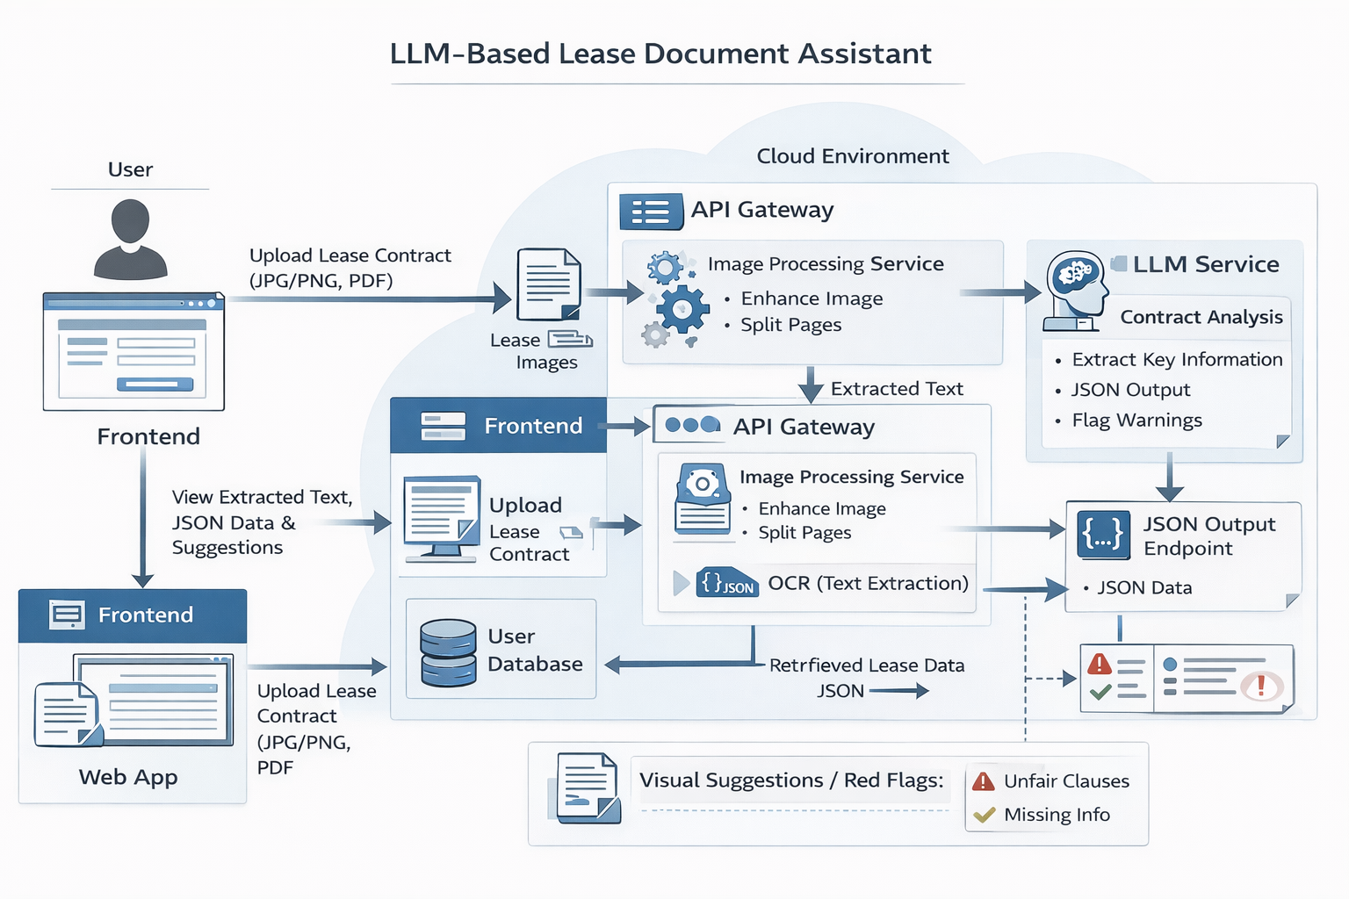

Figure 1: System Architecture of the LLM-Based Car Lease Contract Review
4.BACKEND IMPLEMENTATION
Backend Design:
The backend is implemented using FastAPI, which provides a high-performance REST API. Tesseract OCR converts uploaded images into machine-readable text. Text preprocessing removes duplicate lines and corrects OCR errors. Regular expressions are used to extract agreement details, vehicle information, financial terms, mileage allowances, and insurance requirements. The extracted data is structured into a JSON response for easy interpretation.

5.ACCURACY ESTIMATION
Accuracy Logic:
Accuracy is calculated on a per-field basis. If a lease attribute is successfully extracted, it is assigned 100% accuracy; otherwise, it receives 0%. The overall accuracy is calculated as the average of all fields. This method ensures transparency and allows users to understand how reliable the extracted information is.

6. Fairness Algorithm & Red Flags
6.1 Fairness Algorithm
The system employs a rule-based fairness evaluation mechanism to ensure ethical, transparent, and explainable contract analysis. This algorithm examines lease agreements to determine whether contractual obligations are reasonably balanced between involved parties. It also verifies the presence of essential clauses, including insurance coverage, renewal options, and clearly defined responsibilities. Additionally, the system assesses whether imposed penalties are proportionate and aligned with standard contractual practices.

6.2 Red Flags Detection

The system identifies and highlights potential risk indicators (red flags) within lease contracts. Red flags are triggered when the analysis detects excessive late payment penalties, ambiguous or unclear termination clauses, undefined mileage or usage penalties, or missing insurance requirements. These warnings enable users to quickly recognize potentially unfair or high-risk agreements and support informed decision-making.

7.CONCLUSION & FUTURE SCOPE
Conclusion:
The LLM-Based Car Lease Contract Review System provides an intelligent, transparent, and fair solution for understanding lease agreements. By combining OCR, structured extraction, fairness evaluation, and red-flag detection, the system empowers users to make informed decisions.
Future Enhancements:
- Support for multi-page PDF documents
- Advanced machine-learning-based accuracy estimation
- Legal clause benchmarking
- Multilingual document analysis

